* Parcel library

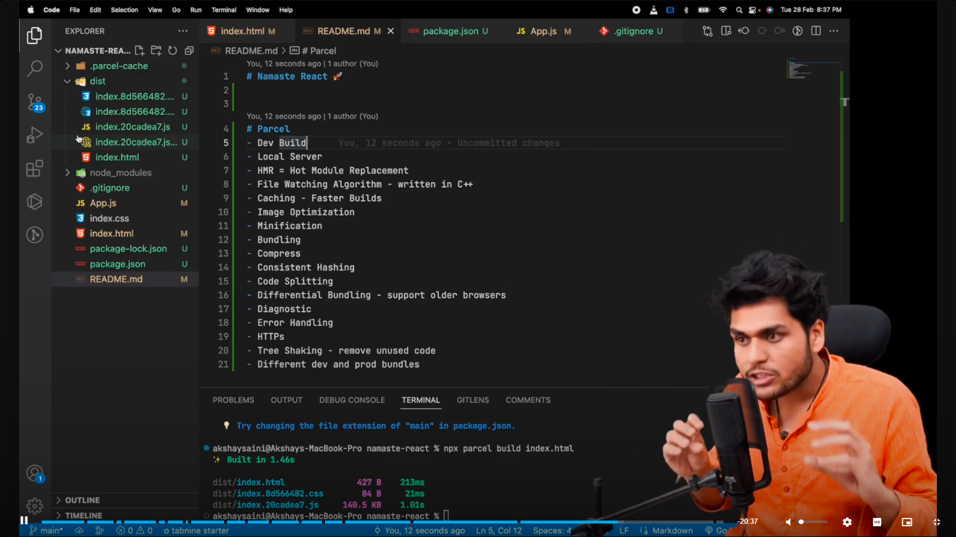

* Browser list – It is package used to tell app that on which versions of broser the app will work.

We have to add configuration in the package.json file.